Table of Contents

1,实验目的 1

2，实验环境 1

2.1，系统 1

2.2，所需额外安装包 1

3,实验步骤 1

1,Software Requisition 2

2,Software Installtion 2

3.1，安装软件 3

3.2，安装php依赖包 3

3.3，然后安装zabbix软件 4

3.4，启动mysql，创建数据库 4

3.5导入初始化数据： 4

3.6, 配置数据库： 4

# 1,实验目的

通过zabbix实现对系统的监控

# 2，实验环境

## 2.1，系统

rhel6.4最小化安装系统，yum已配好

## 2.2，所需额外安装包

php-mbstring-5.3.3-26.el6.x86_64.rpm

php-bcmath-5.3.3-26.el6.x86_64.rpm

# 3,实验步骤

# 1,Software Requisition

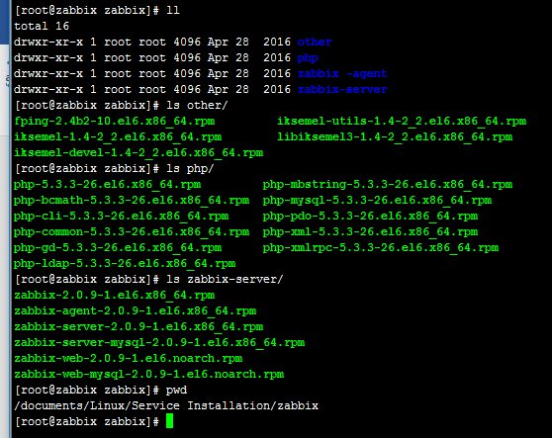

# 2,Software Installtion

yum install httpd php mysql mysql-server php-mysql php-gd php-xml php-mbstring php-ldap php-pear php-xmlrpc php-bcmath mysql-connector-odbc mysql-devel libdbi-dbd-mysql net-snmp-devel curl-devel mod_ssl mod_perl mod_auth_mysql net-snmp -y

yum install php*

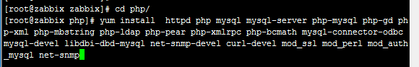

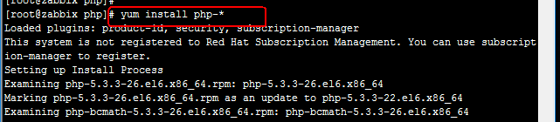

yum install *

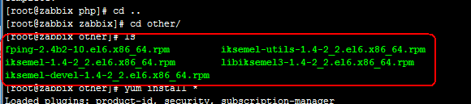

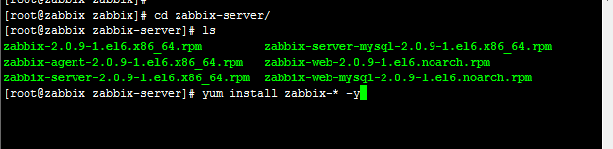

## 3.1，安装软件

这里要安装很多包

yum install httpd php mysql mysql-server php-mysql php-gd php-xml php-mbstring php-ldap php-pear php-xmlrpc php-bcmath mysql-connector-odbc mysql-devel libdbi-dbd-mysql net-snmp-devel curl-devel mod_ssl mod_perl mod_auth_mysql net-snmp -y

## 3.2，安装php依赖包

[root@os0 php]# ls

php-5.3.3-26.el6.x86_64.rpm php-mbstring-5.3.3-26.el6.x86_64.rpm

php-bcmath-5.3.3-26.el6.x86_64.rpm php-mysql-5.3.3-26.el6.x86_64.rpm

php-cli-5.3.3-26.el6.x86_64.rpm php-pdo-5.3.3-26.el6.x86_64.rpm

php-common-5.3.3-26.el6.x86_64.rpm php-xml-5.3.3-26.el6.x86_64.rpm

php-gd-5.3.3-26.el6.x86_64.rpm php-xmlrpc-5.3.3-26.el6.x86_64.rpm

php-ldap-5.3.3-26.el6.x86_64.rpm

[root@os0 php]#yum install php-* -y

还需要安装这些包

[root@os0 rpms]# ls

fping-2.4b2-10.el6.x86_64.rpm

iksemel-1.4-2_2.el6.x86_64.rpm

iksemel-devel-1.4-2_2.el6.x86_64.rpm

iksemel-utils-1.4-2_2.el6.x86_64.rpm

libiksemel3-1.4-2_2.el6.x86_64.rpm

yum install fping iksemel OpenIPMI* dejavu-sans-fonts -y

把上面这些包没装好的逐个安装

yum install libiksemel3-1.4-2_2.el6.x86_64.rpm

yum install iksemel-*

## 3.3，然后安装zabbix软件

[root@os0 rpms]# ls

zabbix-2.0.9-1.el6.x86_64.rpm

zabbix-agent-2.0.9-1.el6.x86_64.rpm

zabbix-server-2.0.9-1.el6.x86_64.rpm

zabbix-server-mysql-2.0.9-1.el6.x86_64.rpm

zabbix-web-2.0.9-1.el6.noarch.rpm

zabbix-web-mysql-2.0.9-1.el6.noarch.rpm

[root@os0 rpms]# yum install zabbix-* -y

## 3.4，启动mysql，创建数据库

[root@os8 rpms]# mysql -e " create database zabbix character set utf8;"

[root@os8 rpms]# mysql -e " grant all privileges on zabbix.* to zabbix@localhost identified by 'zabbix';"

[root@os8 rpms]# mysql -e " flush privileges

## 3.5导入初始化数据：

# cd /usr/share/doc/zabbix-server-mysql-2.0.9/create && mysql zabbix < schema.sql && mysql zabbix < images.sql && mysql zabbix < data.sql "

## 3.6, 配置数据库：

# vim /etc/zabbix/zabbix_server.conf

DBHost=localhost

DBName=zabbix

DBUser=zabbix

DBPassword=zabbix

3.7,启动服务：

# service zabbix-server start

# chkconfig zabbix-server on

3.8,配置php时区：

# vim /etc/httpd/conf.d/zabbix.conf

php_value date.timezone Asia/Shanghai

3.9,重启apache:

# /etc/init.d/httpd restart

3.10,浏览器：

http://192.168.0.21/zabbix/

默认用户名为 Admin,密码为 zabbix。